***Library Management System for Stanford***

Simplilearn CBAP Certification Project - 2

Submitted by

**Mohamed Jasir**



**INDEX**

* **Introduction**
* **Task 1 - Identifying stakeholders – Create a list of stakeholders (as taught in Business Analysis Planning and Monitoring Knowledge Area)**
* **Task 2 - Identify the problem statement in this system**
* **Task 3 - Identify advantages of the new Library Management System**
* **Task 4 - Create as-is and future process map (using flowcharts). You can use any of the popular tools in the market like Microsoft Visio, Lucid Chart, Creately, Pidoco, or Balsamiq**
* **Task 5 - As a Business Analyst working on this project, find out the scope of the Library Management System. To find the scope you can use Use Case diagram (UML) or Context diagram**
* **Task 6 -Write down the main features that need to be developed**
* **Task 7 - Write the in-scope and out-of-scope items for this software**
* **Task 8 - Draw a data flow diagram for the system**
* **Task 9 - Draw an ER diagram of the system**
* **Task 10 - Write out the Business Requirements, both Functional and Nonfunctional Requirements**
* **Task 11 - Draw wireframes or mock screens for any 2 of the features namely book record creation and any other feature as deemed fit by the student. (Use the technique prototyping or wireframing that is taught in the training). You can use any of the wireframing tools like Microsoft PowerPoint, Microsoft Word, Balsamiq, Sketch, Adobe XD, Adobe Illustrator, Figma, UXPin, InVision Studio, InVision Freehand, or Moqups**

**Introduction**

Stanford University is a private research university in California. The university was founded in 1885 and as of today, 83 Nobel laureates, 28 Turing Award laureates, and 8 Fields Medalists have been affiliated with Stanford as students, alumni, faculty, or staff.

For the benefits of the students Stanford started its own library in 1885. The library at Stanford was housed in one large room capable of accommodating 100 readers. As the university grew to enroll more than 20,000+ students in a given year the library grew as well. Today the library boasts of having more than 4 million books in it.

The paper based maintaining, organizing, and handling of countless books became a nightmare. The university wanted a Library Management Software to automate their library’s activities. Using the software one can find books with a click, issue/reissue books quickly, and it will manage all the data efficiently using this system. It also provides immediate and accurate information regarding any type of book, magazine, or research paper, thereby saving a lot of time and efforts.

**BACCM Model**

|  |  |
| --- | --- |
| **Need** | **To automate all the library activities with a software to find all the books with one click, issue and reissue books, manage all the data efficiently** |
| **Change** | **The change is from a physical management of all the books with alot of employees to a software that manages all the library activities that saves time** |
| **Solution** | **The solution is a library management software that makes it easy to find the books with a click, to issue and reissue books easily and to maintain all data of books and users.** |
| **Context** | **The context here is that the employees in the library find it extremely tiring to maintain all the books which exceeds 4 million, to find the books, to keep issue and reissue data for future use , so they need a library management software for book managing and maintain data with ease** |
| **Value** | **It aims on reducing the cost, improving student engagement, increase productivity of library staff and up to date records of all the materials** |

**Task 1 - Identifying stakeholders – Create a list of stakeholders**

**RACI Matrix:**

|  |  |  |  |  |
| --- | --- | --- | --- | --- |
| **Stakeholders** | **Responsible** | **Accountable** | **Consulted** | **Informed** |
| **Regulator** |  |  | **C** |  |
| **Business Analyst** | **R** |  |  |  |
| **Domain SME** |  |  | **C** |  |
| **LMS Manager** | **R** |  |  |  |
| **Student** |  |  |  | **I** |
| **Technical team** | **R** |  |  |  |
| **Tester** | **R** |  |  |  |
| **Sponsor** |  |  |  | **I** |
| **Implementation SME** |  |  | **C** |  |
| **Library staff** |  |  |  | **I** |
| **Project manager** |  | **A** |  |  |

Onion Diagram:

Student , Regulator

Sponsor, Implentation SME, Domain SME

LMS manager, Staff

Tester,Technical team,Business analyst, Project manager

LMS

**Task 2 - Identify the problem statement in this system**

* Problems with manual library:
* A lot of time is wasted managing the manual library.
* The number of employees needed to manage the library is high.
* Fine calculation is a tedious and time-consuming affair.
* No reports could be generated on books issued due to the manual system.
* It is difficult to manage 4 million books present in the library.
* Students could deposit the books only in the library timings.

**Fishbone diagram:**

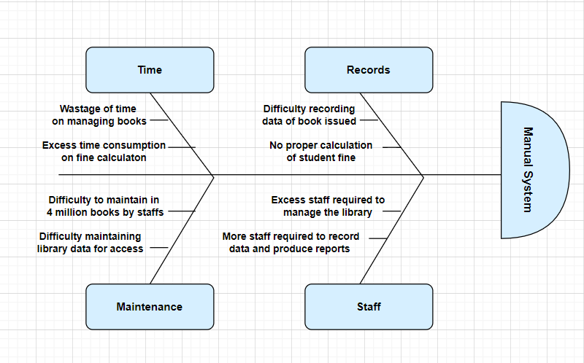

**Task 3 - Identify advantages of the new Library Management System**

**Advantages of Library Management System:**

* Reduce overheads and increase productivity of library staff
* Cost reduction
* Up-to-date records of all books, research papers, magazines, and other materials available in the library
* Improve student engagement in the library
* It will generate dynamic reports for better decision-making

**Task 4 - Create as-is and future process map (using flowcharts)**

**Existing System :**

The existing system, data collected and understanding of wastage are depicted using the below process flow

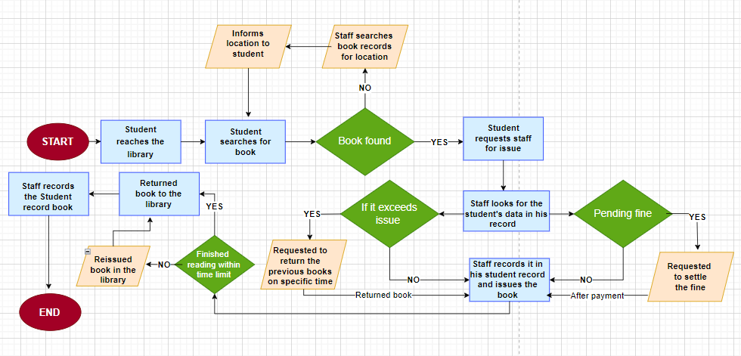

**Proposed System :**

The Future State system has been depicted using the below flow diagram:

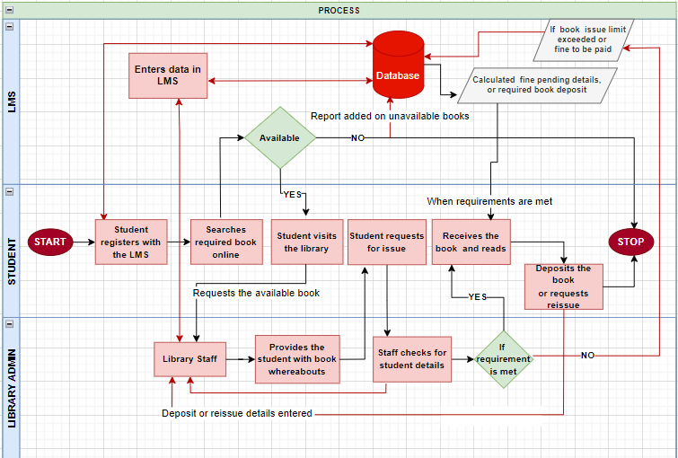

**Task 5 - As a Business Analyst working on this project, find out the scope of the Library Management System. To find the scope you can use Use Case diagram (UML) or Context diagram**

Illustrated below is a context diagram showing the interaction between various actors and functionalities expected from the Canteen Ordering System:

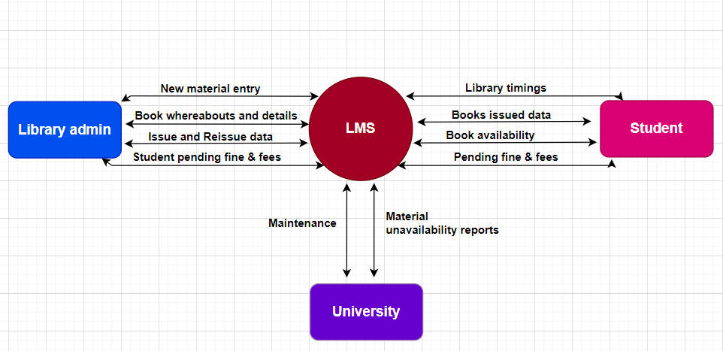

**Task 6 -Write down the main features that need to be developed**

Listed below are the primary features that need to be developed within this solution system;

1. The LMS should keep records of different categories of material available in the library like books, magazines, research papers, journals, and newspapers and classified subject wise
2. Every reading material available shall have a RFID tag on it. The record of the same will be stored in the database. For each reading material record information like author, book name, publisher name, book edition, date and year of publication, cost of the book, and date of purchase of the book
3. The library staff will use a RFID reader to capture the details of the book. The student's name is tagged along with the book they borrowed.
4. System shall do an automatic calculation of fines in case of delayed return of books
5. Library staff should be able to search for books on the LMS by search criteria like name of the book or author.
6. Students should be able to access the library system online to know the return date. They should be able to access it via the web or mobile interface
7. System shall send automated emails to the students 3 days before the return date to avoid late return of books.
8. Access to free e-journals and e-books through the software
9. Anti-theft detection: RFID readers are placed at the exit gate of the library and the RFID reader tracks books to a range of 2 meters and would trigger the alarm with a loud sound in case anyone tried to pass through the gate with an unissued book
10. Book drop box stations to be installed outside the library: Students can return books at any time in the RFID enabled book drop box station. Student’s loan is immediately cancelled once the student deposits the book in the drop box.

**Task 7 - Write the in-scope and out-of-scope items for this software**

**In scope items:**

* LMS Software
* User friendly interface and self-explanatory
* RFID Reader
* Drop Box
* Fine Calculation Feature
* Windows & MacOS supportive
* Cloud storage
* Automatic reminder of emails
* Easy Database Maintenance
* Highly Secured, scalable and reliable
* Generate dynamic reports

**Out scope items:**

* Books for sale
* Lending newspapers
* Access for outsiders
* Memberships
* Mobile application
* User donation of books

**Task 8 - Draw a data flow diagram for the system**

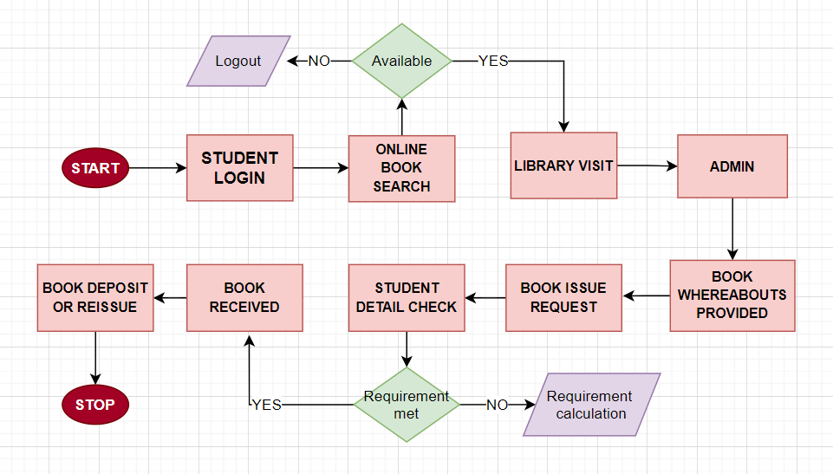

**Task 9 - Draw an ER diagram of the system**

Below ER diagram explains the relationships between the various entities and data sets:

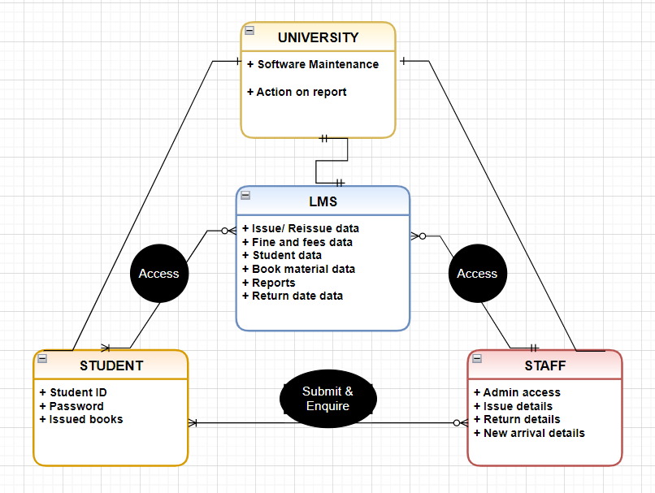

**Task 10 - Write out the Business Requirements, both Functional and Nonfunctional Requirements**

**Functional Requirement:**

* Availability of different categories of material
* Subject wise classification of books
* Different issuing period for different kind of materials
* RFID tag on every material
* Record of issue and return date
* Automatic calculation of fees and fine
* Book details by system search
* Return date access through LMS
* Automatic email remainder ( 3 days before the return date )
* Access to free journals and ebooks
* Anti theft detection with RFID tag
* Book drop box stations outside the library for anytime return

**Management requirements**

* Management would like the following reports:
* Which books are most rented?
* Records of issued and unissued materials in the library (management will decide whether to stock them or not)
* Amount of fine collected in a day, week, and month.
* Number of lost books
* Report on total number of books, journals, etc.
* Age of books, that is, which books are more than 20 years old. College generally would prefer not to have very old books since new versions come up every few years.

**Non -Functional Requirement:**

* Highly secure, scalable, and reliable
* Security system on LMS
* Admin training for LMS usage
* Maintaining system capacity

**Task 11 - Draw wireframes or mock screens for any 2 of the features namely book record creation and any other feature as deemed fit by the student.**

